Gemini A.I. Tutoring Plan: System of Linear Equations

1. **Basic Understanding:**
   * **Prompt Example (what to ask the AI):** "Hi I am a high school student struggling to learn systems of linear equations in my math class can you please teach me substitution, elimination, and graphing. With examples, step to step guidance and visual aid."
   * **Possible Follow-up Question:** "Can you give me an example of a system of linear equations?"
2. **Solving Methods:**
   * **Substitution:**
     + **Prompt:** "Explain the substitution method for solving systems of linear equations."
     + **Example follow up question:** "Solve the system: 2x + y = 5 and x - y = 1 using substitution."
   * **Elimination:**
     + **Prompt:** "Explain the elimination method for solving systems of linear equations."
     + **Example:** "Solve the system: 2x - y = 4 and 2x + y = 12 using elimination."

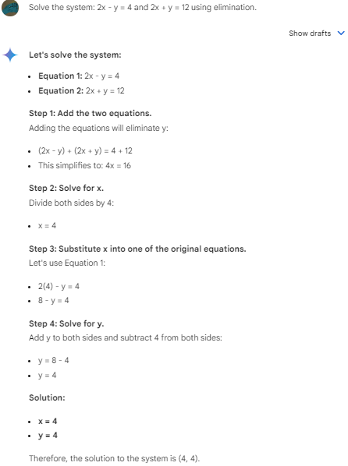

* + **Graphing:**
    - **Prompt:** "Explain how to solve a system of linear equations graphically."
    - **Example:** "Graph the system: y = 2x + 1 and y = -x + 4 and find the solution."

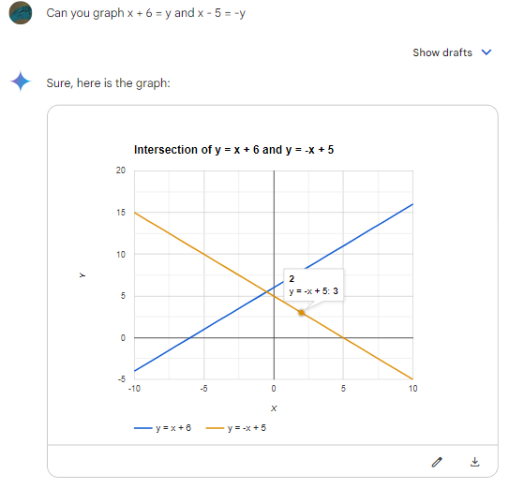

1. **Choosing the Best Method:**
   * **Prompt:** "How do I choose the best method (substitution, elimination, or graphing) to solve a system of linear equations?"

### **Interactive Elements**

1. **Quizzes:**
   * **Prompt:** "Can you give me a 3-question quiz on solving systems of linear equations?"

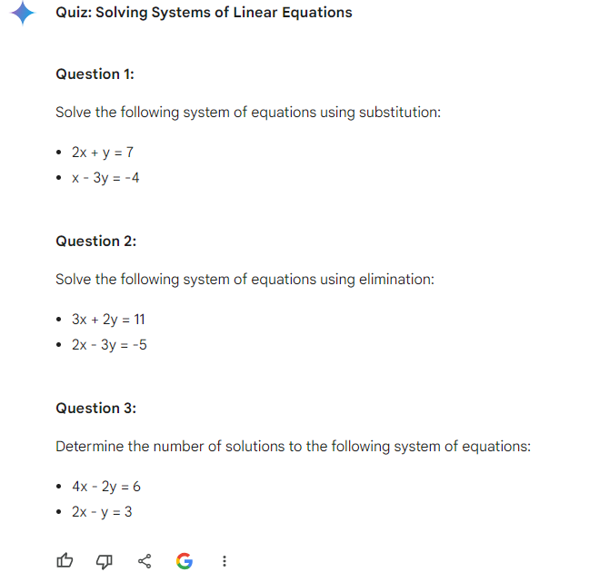

* + **Follow-up:** "Can you provide feedback and explanations for my answers?"

1. **Visual Aids:**
   * **Prompt:** "Can you show me a visual representation of how to solve a system of linear equations using substitution?"
   * **Follow-up:** "Can you create a graph of the system of equations I provided?"

**How to see a visual graph using AI:** You must give an equation for the AI to graph and ask it to graph it. You cannot ask it to graph and explain it in the same message; however you can ask it to elaborate in other messages.

(An image of a graph is provided in the graphing section above)

1. **Gamification:**
   * **Prompt:** "Can you create a game/challenge related to solving systems of linear equations for me to play with you?"

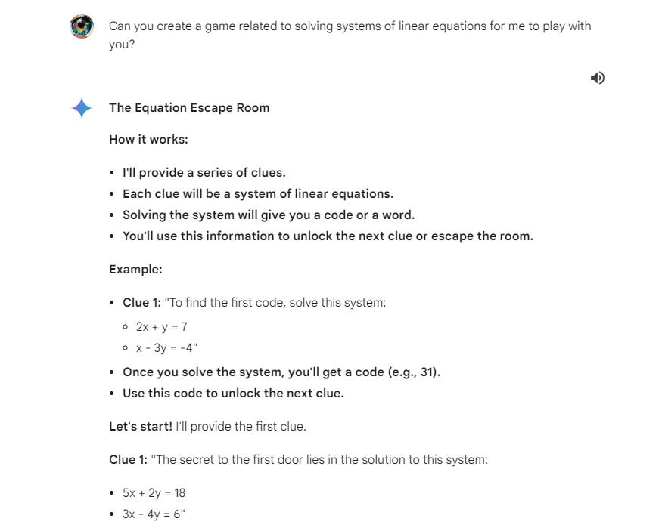

* + **Example:** "Can you create a timed quiz with increasing difficulty levels?"

### **Personalized Practice**

1. **Skill Level Assessment:**
   * **Prompt:** "Can you assess my understanding of systems of linear equations?"

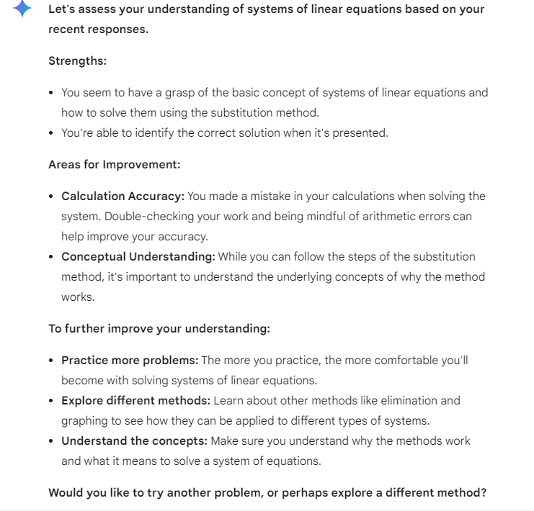

1. **Adaptive Practice:**
   * **Prompt:** "Can you provide practice problems that are tailored to my skill level?"
   * **Follow-up:** "Can you adjust the difficulty of the problems based on my performance?"
2. **Instant Feedback:**
   * **Prompt:** "Can you provide instant feedback on my answers to the practice problems and explain how to get the correct answer if I am wrong?"

